Anthony Berru
Compressor Servicing Instructions
As a current maintenance technician, I have been given various jobs that require me to maintain equipment for companies. One task that I found is simple, but preventative maintenance is servicing an air compressor. The audience this is best for would be anyone that has an air compressor, knows someone with an air compressor, or anyone looking to enter into the maintenance technician field. This sounds like a small group of people, but surprisingly, there are a lot more people within these areas than one would first have thought.
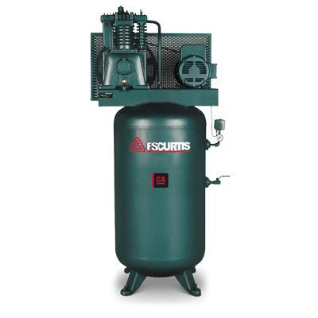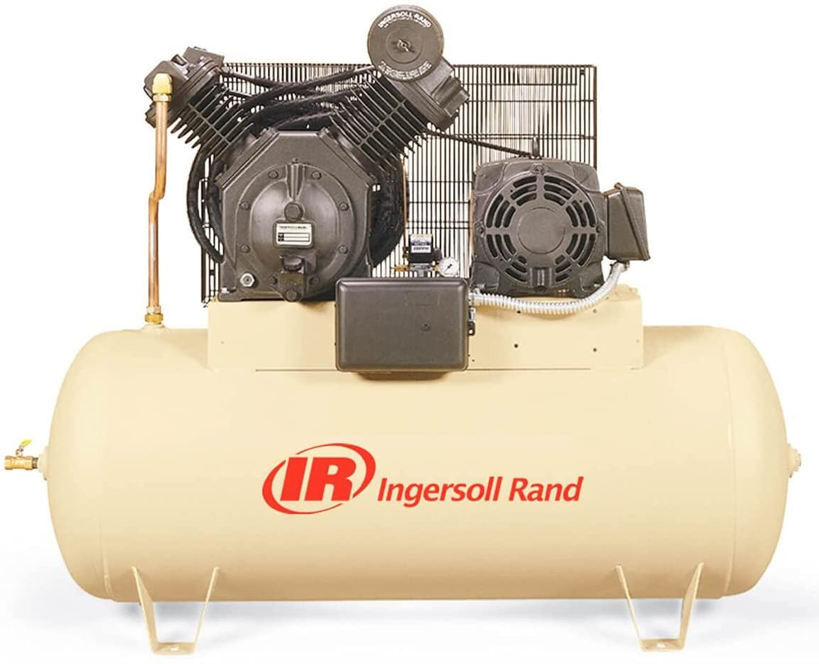
Summary:
This manual is for anyone that owns or knows someone that owns a compressor. These instructions are made specifically for those with a basic knowledge of compressors and new users. Everyone has to start from the beginning, and there is nothing wrong with that. The simplest instructions are change the filters and the oil while making sure to wipe the unit down. The instructions of what to do and where to find specific things follow this summary.
Items needed:
Oil- Generally speaking, it is best to use up to 30 weight oil for your compressor. But regular motor oil is not good, mostly because of the foaming it causes.
Air Filter- the air filter could be several different sizes. This is why it is best to get the Manufacturer, Model, and Serial before attempting to service the compressor.
Rags- To wipe down the unit.
Funnel- This helps with draining the oil out of the compressor and adding the oil back in.
Crescent wrench
Pipe wrench
Bucket or container for old oil

Instructions:
  - When approaching the compressor, be sure to maintain some distance from the compressor until the shut off switch is located and the vehicle is shut down.

  - Wipe down the unit with a rag. While wiping the unit down, observe the unit for any breaks, leaks, wires showing.
**Another thing to do while wiping the unit down is note the name of the manufacturer. The manufacturer name is usually on the air tank. If the name is not there, check the base of the pump. A 2”x3” placard should have the make and model of the compressor along with the manufacturers name.

  - On the upper section of the pump, there will be one or two metal containers that are being held on by wing nuts. These should only be hand tight. Loosen them to see the air filters. Remove the old filters, wipe the inside of the filter containers out and the lid that holds them in place. Replace the old filters with new ones. Once this is done, the caps can be put back in place and the wing nuts tightened.
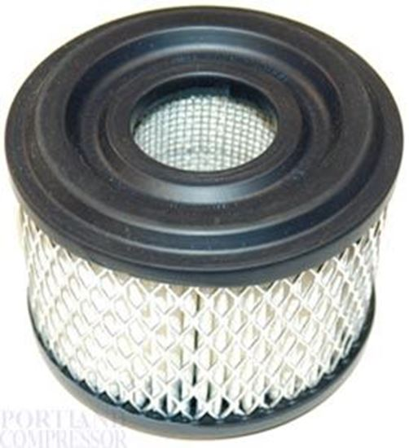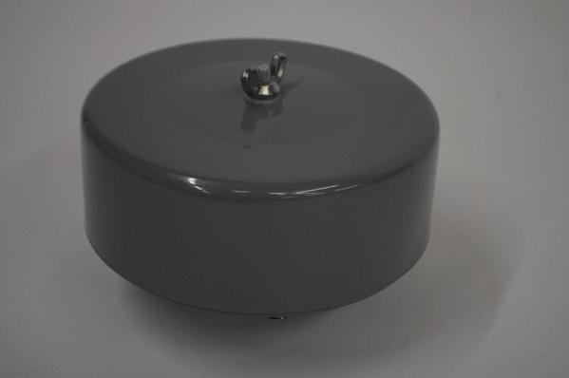

  - The oil tank will be located on the bottom of the pump. There will be a small pipe sticking out of the bottom of the pump with a closed ended nut. BE SURE TO HAVE THE BUCKET READY AS THE OIL WILL COME OUT THE MOMENT THAT NUT IS REMOVED. Remove nut and let the compressor drain completely. A good way to know is when the oil stops pouring out and begins to drip. Put the nut back on the pipe and tighten the nut.
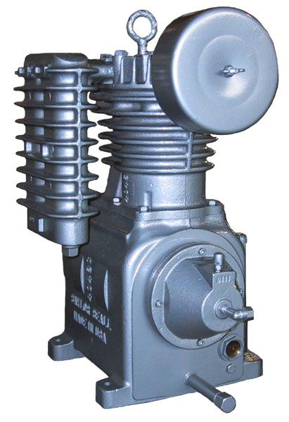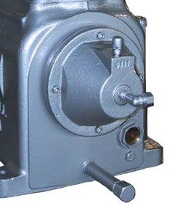
  - Look on the right side of where the pipe is located for a small gauge indicating the oil level. Either on the top of the pump, or on the lower section next to the pipe the oil drained from, there will be another nut that can be removed. Remove this nut and put in the funnel. If there is a gauge, fill the oil to the bottom of the “O” in the “Oil Level.” If there isn’t a gauge, fill the oil tank to the bottom thread. This is the general rule that can be followed. Tighten the nut back onto the oil tank.

  - Check for a Low oil control which would be located on the side of the pump or within the gauge. Hold the button down for ten seconds if there is a button. There may be a small white plastic bolt that needs to be twisted and held for ten seconds. This resets the oil gauge for the pump.

  - Check the belts connecting motor and the pump. See if there are any tears, cracks, or breaks in them. Make sure the cage that covers the belts is tight and not pushing against the belts. Make sure the belts are straight.

  - Turn on the shut off switch, the compressor should turn on if there is little to no air. While the compressor is on; listen for whistling, look at the top of the pump for any leaks or bubbles coming from the seals, listen for squeaking belts.

  - Verify that the system stays on and shuts off at a designated air limit, roughly 175 PSI. When this occurs, the compressor is safe to use.

Troubleshooting:
While the step-by-step process is simple, the difficult part comes when the machine is turned back on. Different sounds could mean different things. The following are some of the most common noises and what they mean. *Note: these are all found on a pump air compressor. Not all of them would be noticeable on a rotary screw compressor.
Squeaking when the compressor turns on. The squeaking is because the belts connecting the motor and the pump are loose or the belts are crooked. This occurs over time. The fix for this is to either change the belts or to tighten the belts by tightening the bolt holding the motor in place.
Hissing noise while the compressor is on. One of the safety check valves is stuck open. This could be one of two things. The first is the valve’s spring is worn and the valve needs replaced. This is a simple unscrew the old one and screw in the new one. Be sure to check that the new valve is at or above the old valve’s pressure. The second is carbon buildup stuck in the safety valve and needs to be removed. Removing the valve and cleaning the buildup out will help. But if the carbon buildup is occurring, there may be too much oil leaking through the air lines and may need cleaned out.
Sputtering hiss while the compressor is on. One of the safety valves is popping. This happens when the pressure from the pumps is not being relieved inside the pump. This happens when there is a blockage somewhere in the line. The best place to start is the next section in the air line.
Air leak coming from the pump. The way to check for this is placing your hand a few inches from the pump while it is on to feel for air coming out, or if there is some condensation coming from the gaskets, there will be small bubbles forming.

References:
Photo taken from FS Curtis website. https://us.fscurtis.com/product/ca-series/
Photo taken from Ingersoll Rand website. https://www.ingersollrand.com/en-us/air-compressor/reciprocating-air-compressors/electric-driven-duplex
Photos taken from air compressor services. https://aircompressorservices.com/products/ingersoll-rand-filter-replacement-32170953

